**R&D Research**

Focusing on researching the raspberry pi, its OS, the camera lenses, and using Nano detect / YOLO.

Base research on the ‘Body Camera Research’ document in the teamwork portfolio

**Raspberry Pi**

<https://www.raspberrypi.com/products/raspberry-pi-4-model-b/>

**Raspberry Pi Lenses**

Current raspberry pi camera lenses (which need to be purchased separately from the camera, meaning the group will have the option to choose the best camera lens based on the scenarios we create - will be checked with the client.

Most up to date raspberry pi camera:

* <https://www.raspberrypi.com/products/raspberry-pi-high-quality-camera/>
* <https://www.arducam.com/product/arducam-12mp-imx477-mini-high-quality-camera-module-for-raspberry-pi/>

| **Raspberry Pi High Quality Camera** | **Arducam 12MP IMX477 Mini High Quality Camera Module for Raspberry Pi and Pi zero** |
| --- | --- |
| * 12.3 MP * More readily avalible | * 12 MP |

Overview and updated of lenses and what to look for:

<https://www.seeedstudio.com/blog/2020/06/18/a-complete-guide-to-help-you-choose-lenses-for-your-raspberry-pi-high-quality-camera-m/>

* Focal Length

Focal length is the distance between the optical center of a lens and the camera image sensor. Focal length affects how much image area is shown by the camera, higher focal length is more magnified, and lens focal length for a fuller picture

* Angle of view

The angle of view is the area of the scene captured by the image sensor. Wide-angle results in a wider area captured and vice versa for small angles. Focal length is shorter, the angle of view is wider, and when the angle of view is narrower subjects will appear larger

* Effective Focal Length from RPI HQ Camera

Focal length of a camera will change depending on the size image sensors in a given camera. A smaller image sensor will result in a smaller focal length and vice versa. The ‘crop factor also needs to be taken into consideration, example below;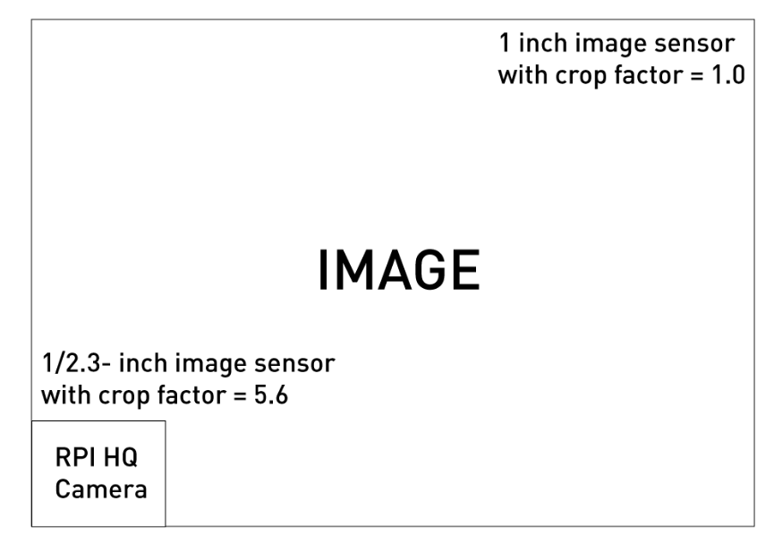

* Image Format

The image format refers to the diameter of the lens. The image format of the lens is again directly effected by the image sensor size. To achieve a complete image, the image format of the lens should be >= the size of the image sensor;

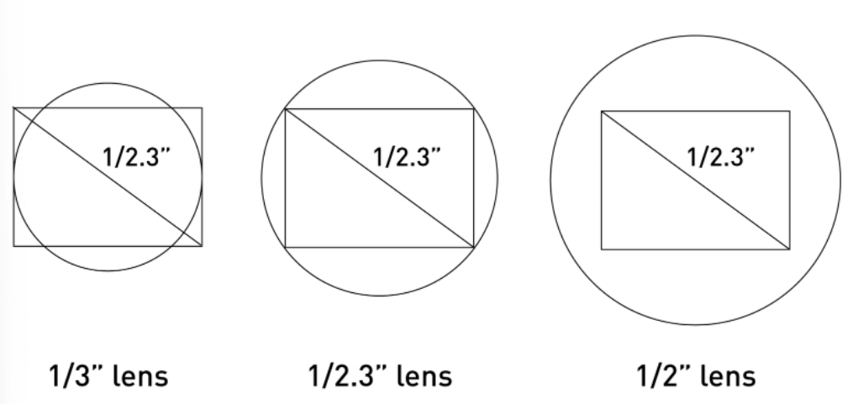

* Resolution

Resolution refers to the amount of detail a given lens is able to capture, therefore, higher resolution is much preferable.

* Aperture

Aperture is related to the size of the opening at the back of a lens and it controls how much light is passed on to the image sensor of the camera. When the aperture opening is narrow, less light is passed through to the image sensor, leading to low exposure. When the aperture is wide, more light and high exposure. Aperture affects depth of field, the image background will be blurred with a wider opening

* Mount Type

Different camera lenses will have different connector types. The raspberry pi high-quality camera is equipped with a CS lens mount by default (keep in mind, can get a C-CS adapter for this camera if the right lens found won't fit.)

* Minimum Object Distance

Minimum Object Distance describes the shortest distance between the foremost lens and the subject which you can still focus on.

Current lenses from the raspberry pi:

* Wide-angle lens (<https://www.adafruit.com/product/4563>)

6mm, has a wide field of view, great for viewing larger areas.

* Telephoto Lens (<https://www.adafruit.com/product/4562>)

16mm, 25mm, 35mm, 50mm 10MP, high level of zoom, good for target-specific subjects located far away.

* <https://www.seeedstudio.com/3MP-8-50mm-C-Mount-Lens-for-Raspberry-Pi-High-Quality-Camera-p-4626.html>

8-50mm 3MP, has an adjustable aperture ring from F1.4.

* Microscope Lens <https://www.seeedstudio.com/Microscope-Camera-300X-C-Mount-Lens-for-Raspberry-Pi-High-Quality-Camera-p-4627.html>

300x, has an adjustable magnification ring which supports magnification up to 300x.

Other lenses that are compatible:

* <https://www.arducam.com/product/arducam-m12-lens-kit-for-raspberry-pi-high-quality-camera-fisheye-wide-angle-telephoto-m12-camera-lenses-with-lens-adapter/>

This is a comparison between all of the M-12 lenses for the raspberry pi, comparison table will be very helpful to refer to if we want to meet specific requirements (note that this link is for multiple camera lenses)

* <https://thepihut.com/collections/raspberry-pi-camera-lenses/products/m12-lens-140-degree-ultra-wide-angle-with-raspberry-pi-hq-camera-adapter>

Another raspberry pi camera designed lens, is an ultra-wide lens and is specified to be “*great for CCTV-style applications where a wide field of view is essential*”. 140-degree wide lens

Camera of Choice: Raspberry Pi High-Quality Camera, while the other camera has the M-12 pack of lenses, the Raspberry Pi has good specs and a wider range of possible lenses and will be more compatible with the raspberry pi that our team will be training models on.

Lens Choice: I think that the standard wide-angle lens will be the best choice for all-around detection, especially considering we will be wanting to see more of a peripheral vision of the employee wearing the camera. (to check with the client)

<https://www.amazon.com/Raspberry-Industrial-STARVIS-IMX327LQR-Fisheye/dp/B085VLS96S> - a camera to use

**Nano**

* <https://github.com/RangiLyu/nanodet>

**YOLO (v4)**

* <https://github.com/WongKinYiu/PyTorch_YOLOv4>

**Model Training**

<https://create.arduino.cc/projecthub/zoromoth/machine-learning-with-nano-ble-33-raspberry-pi-958b2f>